Create repo in github: simpleMicroservices_starter

Create: questions / index.js

Go to questions/ index.js, in terminal, type: npm init -y

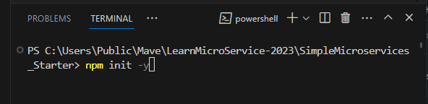  
The above is WRONG!

Need to go into : questions > npm init -y

Then, package.json is created.

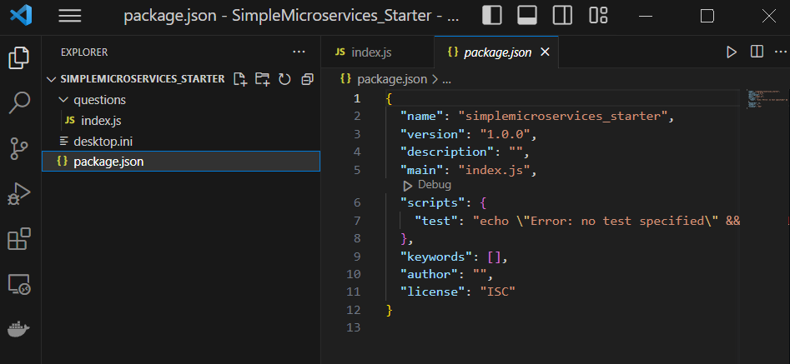

Change: test:…. To : start: nodemon index.js

Then, in terminal: type: npm I, then type: npm install axios cors express nodemon

Return

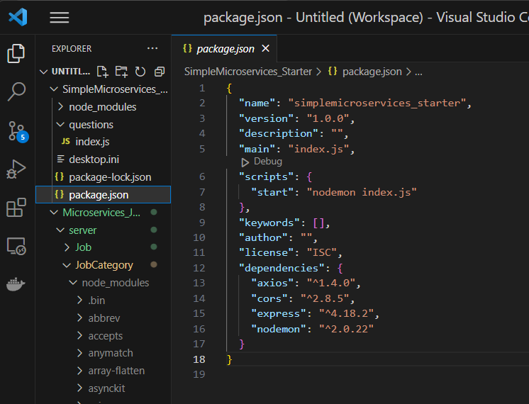

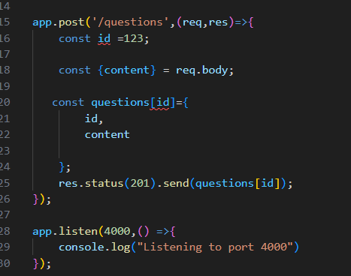

Id is already declared,

But const questions[id] is redeclare, is WRONG

Make the change as below

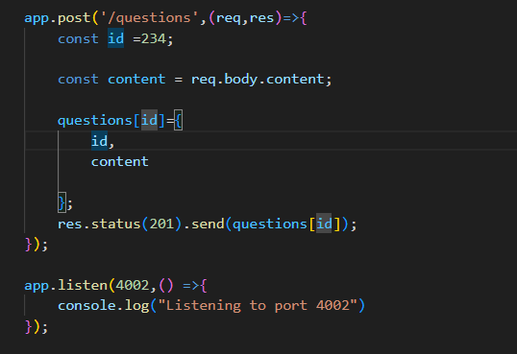

The whole: questions/ index.js

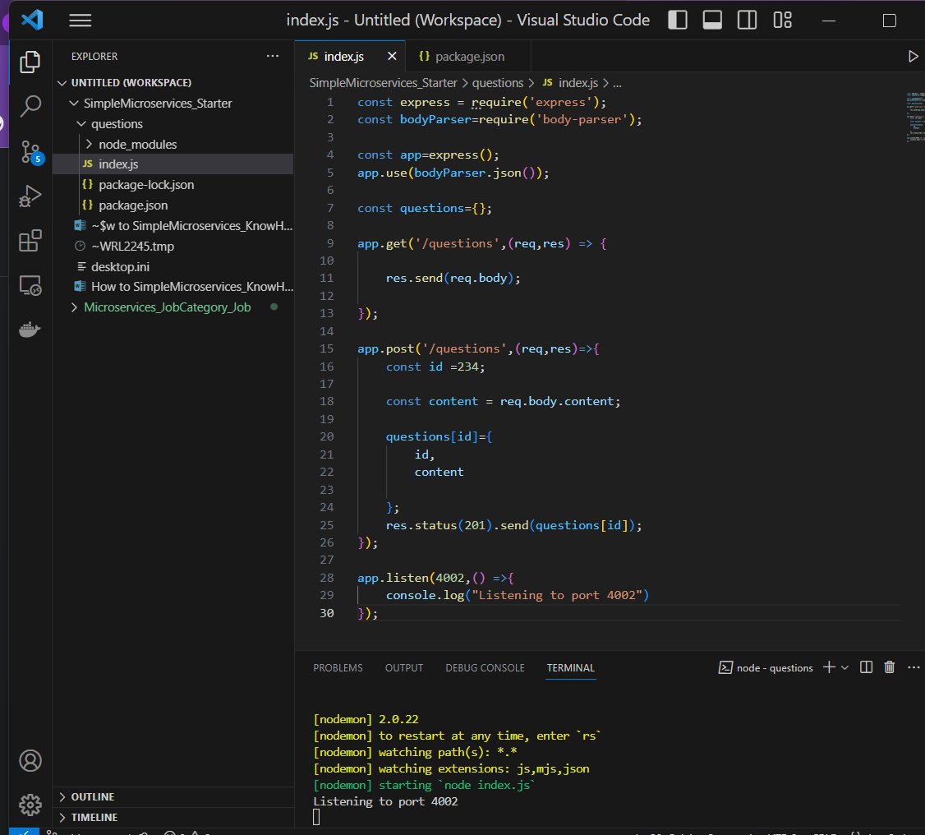

Go to terminal: questions/ npm start

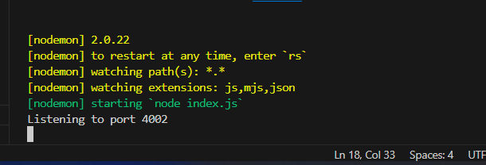

Go to POSTMAN TO test:

